Name_________________________________________________
Nebraska Career Connections
Summary of Test Results
PART 1:
- Go to NebraskaCareerConnections.org > Login
- Click on My Portfolio > Assessment Results
- Click on One Page Summary Report (magnifier icon). Save as a PDF; upload to Google Classroom assignment “NCC Summary Report.”

PART 2: Follow the links below for the Career Interests and Skills Confidence Assessments:
Self-Exploration -> Assessment Results -> Magnifying Glass ->National Cluster Results
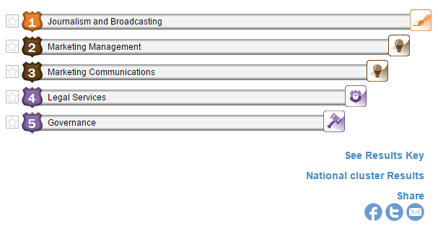
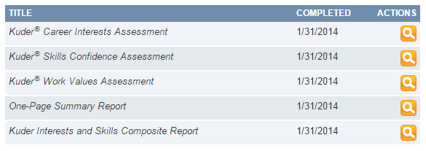

What are your top 3 clusters for INTERESTS? What are your top 3 clusters for SKILLS?
____________________________________ __________________________________
____________________________________ __________________________________
____________________________________ __________________________________
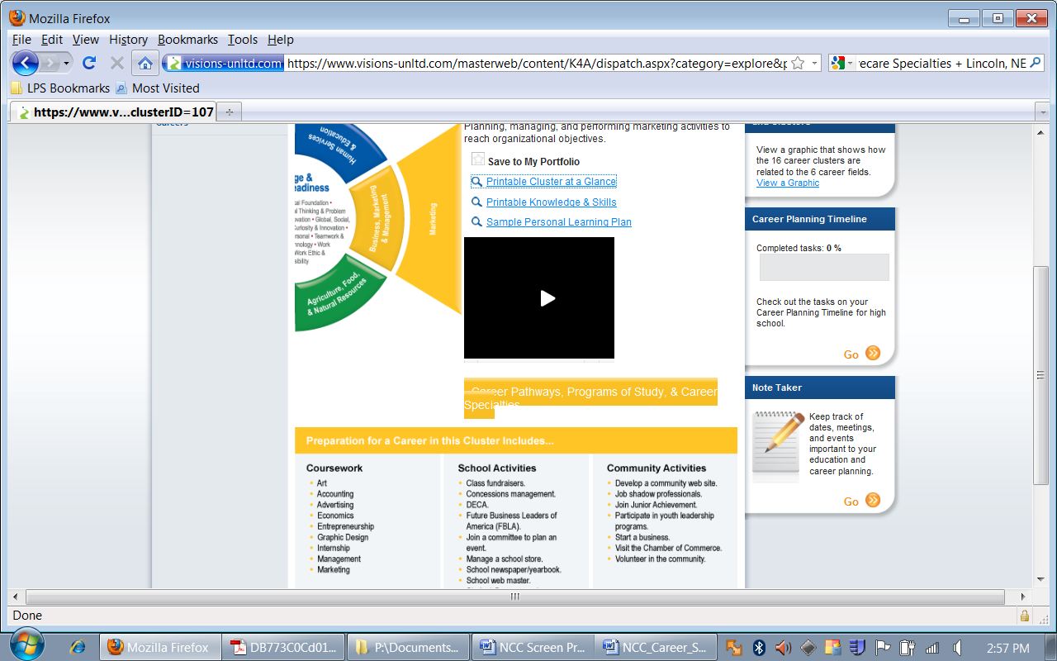

PART 3: Follow tabs and links below to learn more:

Career Exploration→Explore Careers by 16 National career clusters & Pathways
Click on your favorite cluster. Scroll down to the bottom of the screen and identify what you could do to prepare for this Career Cluster (there may be more OR less than 5 of each choose from):

Coursework | School Activities | Community Activities

Have you taken any of the above courses? If so, which ones?
Of the above listed courses, which ones would you consider taking your junior year? Senior year?
What school activities are you currently involved in?
Do these school activities relate to your career? How do they relate? If not, are there clubs at school which relate to your career interests?

Click on your SECOND favorite cluster. Scroll down to the bottom of the screen and identify what you could do to prepare for this Career Cluster (there may be more OR less than 5 of each choose from):

Coursework | School Activities | Community Activities

Have you taken any of the above courses? If so, which ones?
Of the above listed courses, which ones would you consider taking your junior year? Senior year?
What school activities are you currently involved in?
Do these school activities relate to your career? How do they relate? If not, are there clubs at school which relate to your career interests?

