Directions: Using the information you collected last week on Black Friday and Cyber Monday deals, complete the following activities.
Activity 1: Enter and Format Data
- Open a blank Excel spreadsheet and save as “LastName_Thanksgiving” to your Excel folder on Cobra. Enter the following data from your notes into the appropriate cells. Bold the cells that are bolded below.
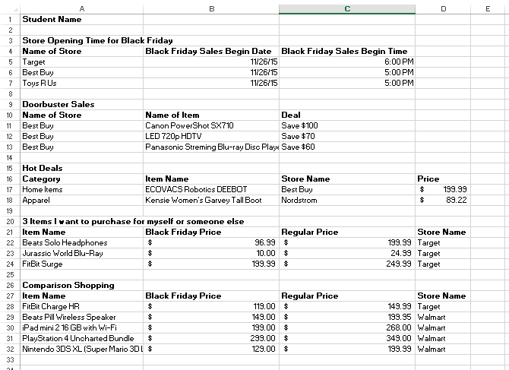
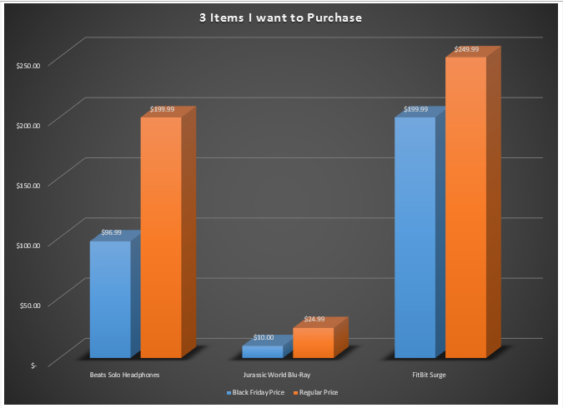
- Format cells that include prices with the ACCOUNTING NUMBER format (should display with Dollar Signs and 2 decimal places).
- Format cells that include the date to show as 1/14/00.
- Format cells that include the time to show as 1:30 PM.
Activity 2: Create Charts
- Select the RANGE A22:C24 and create a 3D Clustered Column Chart
  - Move the chart to a new sheet and name it 3ItemsColumn.
  - Using Quick Layouts – change the layout to Layout 3.
  - Using Chart Styles – select Style 9.
  - Select the Chart Title text and change the title to “3 Items I want to Purchase”
  - Using Chart Elements – check “data labels” so the price of the items show on the chart.
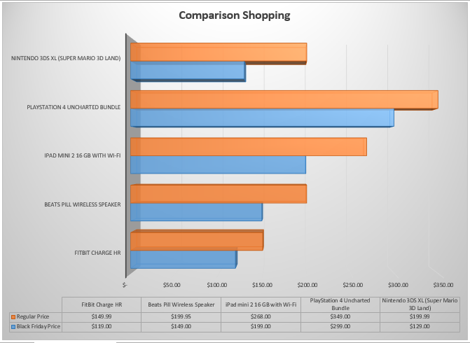
- Select the RANGE A27:C32 and create a 3D Clustered Bar Chart
  - Move the chart to a new sheet and name it ComparisonBar.
  - Using Quick Layouts – change the layout to Layout 5.
  - Using Chart Styles – select Style 3.
  - Select the Chart Title text and change the title to “Comparison Shopping”
When finished, SAVE again and copy completed assignment to your “to be graded”
folder on Cobra.

