Rocket House Brochure Project

Your task:
Using Microsoft Office templates, create a brochure to advertise Rocket House, a program offered to LNE students through the Lighthouse of Lincoln and the Lincoln Sowers Association. Use the tools and techniques you have learned so far in this class to design a unique brochure that represents LNE, Rocket House, and the Lighthouse of Lincoln. Mr. Glathar will be selecting one that will be used and sent to print!
Things to consider:
- Keep It Simple!
- Use Rocket House Logo in your design
- May also use LNE logo (maybe something similar to the letterhead)
- Color choices – again keep it simple – don’t use too many (try to use only 2 or 3)
- Font choices – again keep it simple – don’t use too many (try to use only 1 or 2)
- Be unique, yet appealing – think about the target audience and what information is necessary to include

Information about Rocket House:
How it works:
- Students come to the media center and scan in shortly after school - they should arrive by 3:15
- Students will be asked to use the first 45 minutes to work on projects, research, study, or read quietly
- The second hour is more relaxed with students involved in more social and interactive activities. Some activities will be enrichment activities that deepen and enrich the skills already taught at school. Other activities will consist of board games, card games, hands on things and other activities that are fun
- Hours
  - M-W-Th-F – 3:10 to 5:00 PM
  - Tuesday – 2:10 to 5:00
Benefits to students:
- Students will have the opportunity to work with NHS students, receive tutoring on Tuesdays, and Nebraska Wesleyan practicum teachers will be available on Monday, Wednesday and Thursday.
- Students will be asked to use the first 45 minutes to work on projects, research, study, or read quietly. They may use the technology in the media center with productive purpose.
- Students will have access to an English teacher at the Writing Lab on Mondays, Wednesday, and Thursdays. Teachers are there to support students with all their writing needs.
- Friday’s activities will be enrichment activities that deepen and enrich the skills and knowledge already taught at school.
Rocket House Staff:
- Billy Vrtiska - Assistant Director – Light House
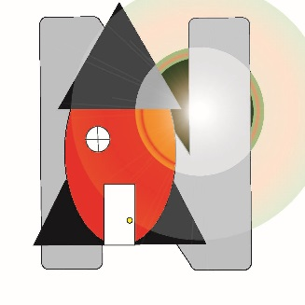
- Amber Weyer – Staff Member – Light House
- Savaughn Miller – Staff Member – Light House
- Jeanette Dorn – LNE Media Specialist

