Certiport Student Account Set Up Instructions

- Visit the Certiport site: www.certiport.com
- Click on the “Register” link toward the top right of the page.
- Select preferred language (English) and country (USA). Then check that you agree to privacy statements and enter the characters you see. Select “Next” at bottom of page.
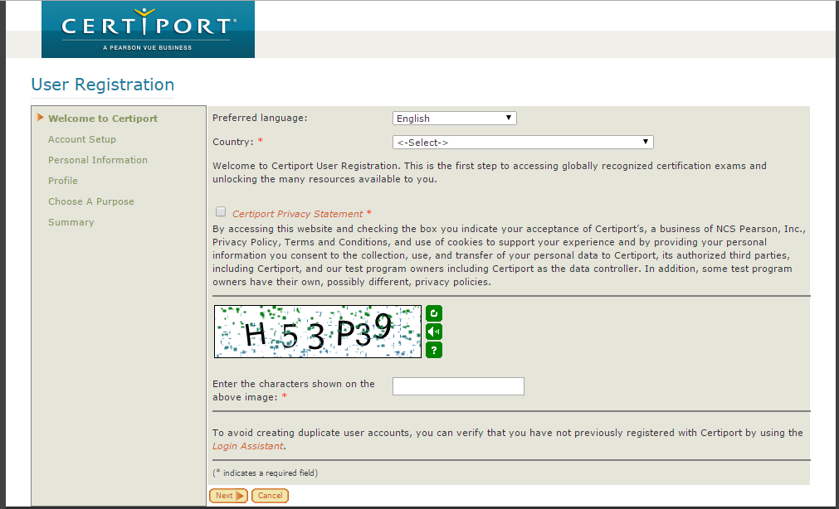
- Enter in your personal information (make sure you capitalize and spell correctly… this is what will appear on your certificates). For your Username, use LPS_StudentID#, for Password, use your LPS Password. Lastly, select 2 security questions and type in the appropriate answers to each. Select “Next” at bottom of page.
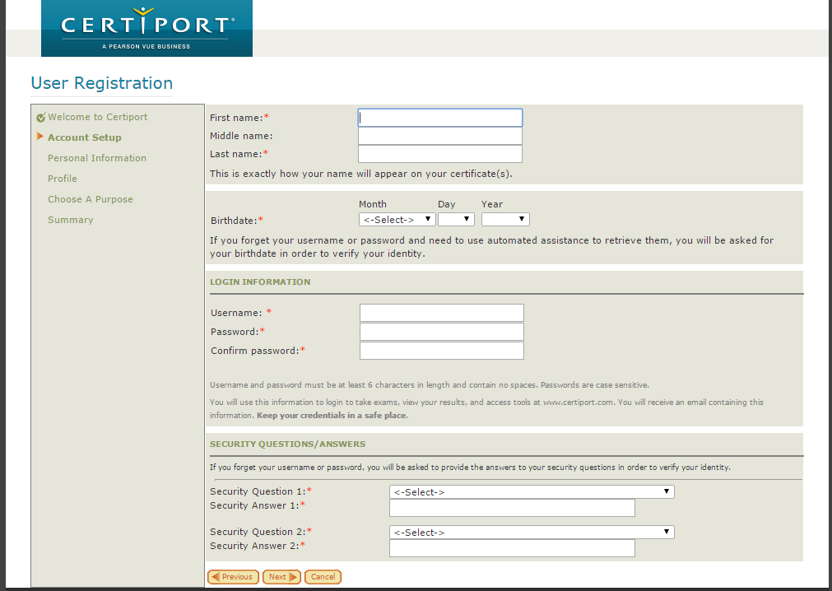
- Enter your LPS email address (StudentID#@class.lps.org) – you do not need to enter in your phone number or Student/Employee ID. Enter in your mailing address, then select “Next” at bottom of page.
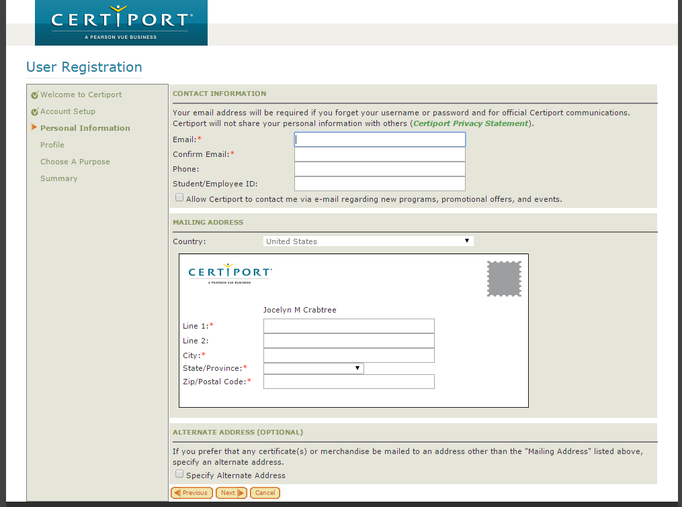

- Select “Yes” to the student question. Select the number of years you have completed in school. If you are a member of one of the student organizations listed, please select it (e.g., FBLA). Then select “No” for employed question and select your appropriate gender. Finally, select “Submit” at bottom of page.
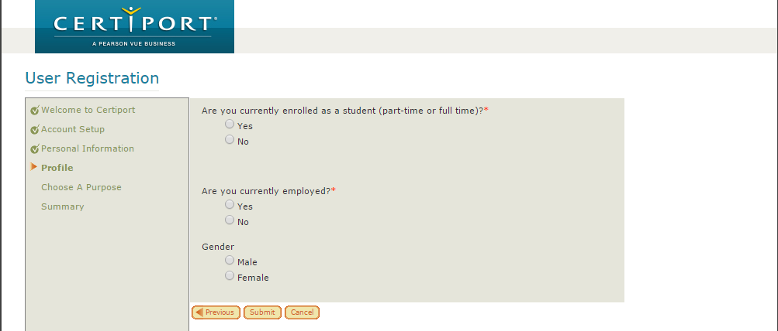
- Check the box next to “Take an exam or prepare for an exam” then select “Next” at bottom of page.
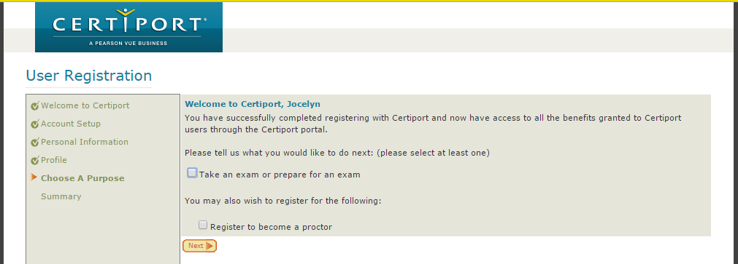
- Select “Register” next to “Microsoft” and a new tab window will open.
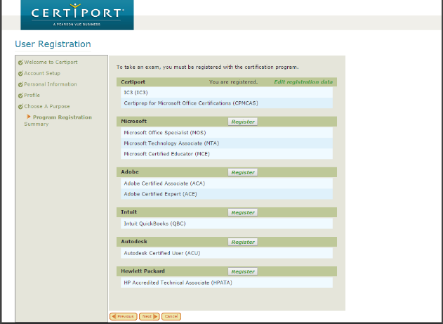

- On the new tab window, select “Use my Certiport data” and it will populate your information for you. Then towards the bottom of the page, click on the red link “Microsoft Non-Disclosure Agreement” and another new tab will open to show you the Non-Disclosure Agreement.
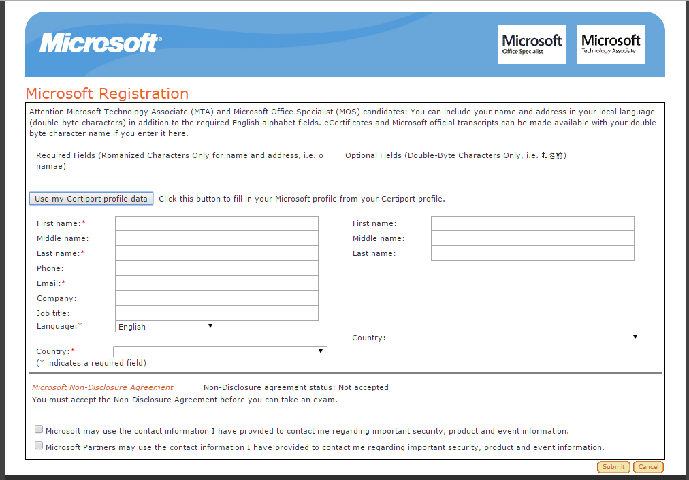
- On the new tab, click “Yes, I accept” – the disclosure agreement window will close automatically.

- Back on the Microsoft Registration window, click “Submit” at bottom of page. That window will then close and you should be back at the original Certiport window.
- Back on the original Certiport window you will notice it now has you registered for Microsoft. Click “Next” at bottom of page.
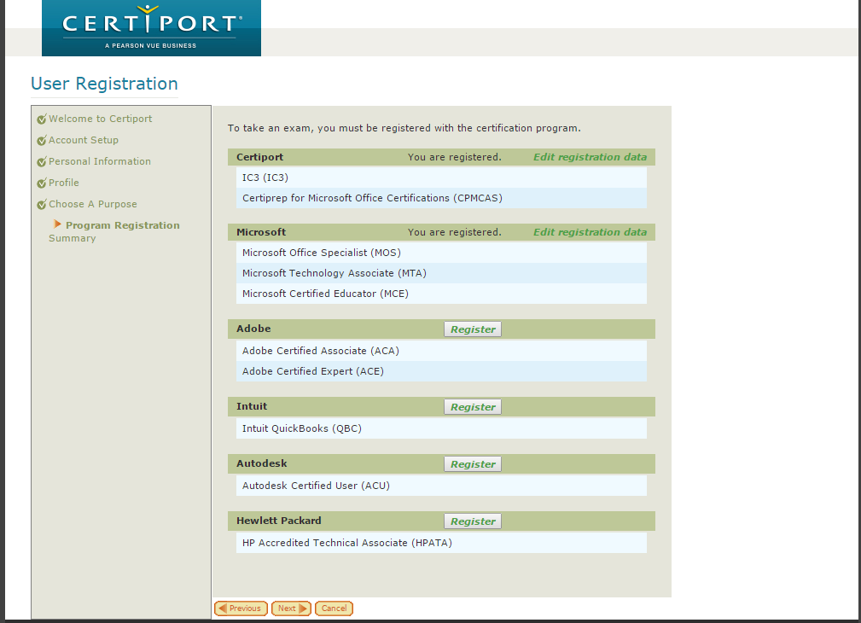
- On the last page you should have a checkmark next to all of the following data. Click “Finish” at bottom of page to complete your Certiport setup.
