**Directions: Have some fun this Thanksgiving with these family traditions. Use the Internet to answer the questions below.**

* **Shopping:** **two of the most successful shopping days of the year are …**

**Black Friday:** The day after Thanksgiving in the United States, where it is the beginning of the traditional Christmas shopping season. Black Friday is not an official holiday, but many employers give the day off, allowing consumers to get a head start on their Christmas shopping. Many retailers open very early (typically 12 a.m.) and offer Doorbuster deals to draw people to their stores. "Black Friday" was originally so named because of the heavy traffic on that day, although most contemporary uses of the term refer instead to it as the beginning of the period in which retailers are in the black (i.e., turning a profit).

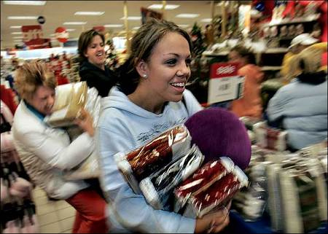**Cyber Monday**: This day refers to the Monday immediately following Black Friday. Whereas Black Friday is associated with traditional [brick-and-mortar](http://en.wikipedia.org/wiki/Bricks_and_mortar_business) stores, "Cyber Monday" symbolizes a busy day for online retailers. The theory was that consumers would return to their offices after the Black Friday weekend, making purchases online that they were not able to make in stores invented by Shop.org. According to Scott Silverman, the Executive Director of the organization, the term was coined based on research revealing that 77% of online retailers reported a significant increase in sales the Monday after Thanksgiving in 2004.

**Be the first to see what great deals you can get during Black Friday, by checking it out online. Visit** [**www.bfads.net**](http://www.bfads.net) **to explore deals and answer the questions below!**

**STORE OPENING TIME FOR BLACK FRIDAY**

**Click on three stores. List three of your favorite stores below and write the time that the store sales begin.**

|  |  |
| --- | --- |
| Name of Store | Black Friday Sales Begin – Time and Date |
|  |  |
|  |  |
|  |  |

**DOORBUSTER SALES**

**Click on Adscans, pick a store (or 3) and find three Doorbuster Deals**

|  |  |  |
| --- | --- | --- |
| Name of Store |  | List one Doorbuster Deal – Time and Date |
|  |  |  |
|  |  |  |
|  |  |  |

**Click on Hot Deals. Pick 2 categories and answer the below questions.**

**Category 1:**

What is an item listed in that category?

Where can you purchase that item?

How much will it sell for?

What are the special features of that product?

**Category 2:**

What is an item listed in that category?

Where can you purchase that item?

How much will it sell for?

What are the special features of that product?

**Additional Black Friday Websites:**



Go to: [www.blackfridayads.com](http://www.blackfridayads.com/) or [www.blackfriday.com/flyers](http://www.blackfriday.com/flyers)

**Name 3 things that you might either want to buy for yourself or someone else on**

**BLACK FRIDAY**

**Item #1**

Name/Description of item:

Black Friday Price:

Regular Price: (might have to use Google/Shopping to compare prices)

Store where available:

Time the doors open:

**Item #2**

Name/Description of item:

Black Friday Price:

Regular Price: (might have to use Google/Shopping to compare prices)

Store where available:

Time the doors open:

**Item #3**

Name/Description of item:

Black Friday Price:

Regular Price: (might have to use Google/Shopping to compare prices)

Store where available:

Time the doors open:

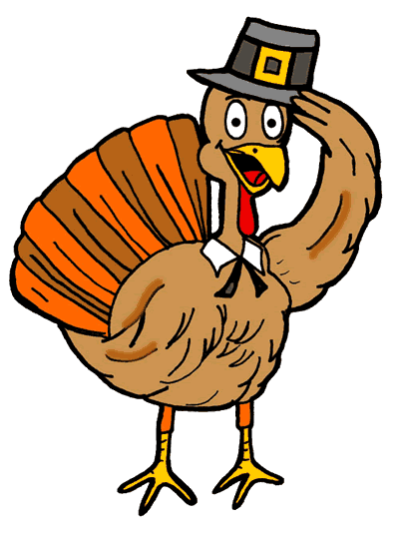**Have a …**

Happy

Thanksgiving



**Be the first to see what great deals you can get during Cyber Monday. Name two (2) things that might either want to buy for yourself or someone else on Cyber Monday.**

**Cyber Monday Websites:**

Go to: [www.cybermonday.com](http://www.cybermonday.com/) or [www.forums.gottadeal.com](http://www.forums.gottadeal.com/)

**Name 2 things that you might either want to buy for yourself or someone else on CYBER MONDAY**

**Item #1**

Name/Description of item:

Cyber Monday Price:

Regular Price: (might have to use Google/Shopping to compare prices)

Store where available: ______________________________________________________________________

URL (remember Cyber Monday items are only available on-line):

**Item #2**

Name/Description of item:

Cyber Monday Price:

Regular Price: (might have to use Google/Shopping to compare prices)

Store where available: ________________________________________________________________________

URL (remember Cyber Monday items are only available on-line):

**Now Comparison Shop**

Select 5 big ticket items (over $100) sold at Wal-Mart, Best Buy, Target, Staples, and Radio Shack for Black Friday and find who has a great deal or sale**:**

**Item #1 ________________________________________**

Regular Price: (might have to use Google/Shopping to compare prices)

Black Friday Price: _______________________________ Store where available: __________________________

Time item is available: ______________________

**Item #2 ________________________________________**

Regular Price: (might have to use Google/Shopping to compare prices)

Black Friday Price: _______________________________ Store where available: __________________________

Time item is available: ______________________

**Item #3 ____________________________________________**

Regular Price: (might have to use Google/Shopping to compare prices)

Black Friday Price: _______________________________ Store where available: __________________________

Time item is available: ______________________

**Item #4 ___________________________________________**

Regular Price: (might have to use Google/Shopping to compare prices)

Black Friday Price: _______________________________ Store where available: __________________________

Time item is available: ______________________

**Item #5 __________________________________________**

Regular Price: (might have to use Google/Shopping to compare prices)

Black Friday Price: _______________________________ Store where available: __________________________

Time item is available: ______________________

Be a little help around the kitchen? **Help carve the turkey, Make the Gravy, Cook the Bird**

Using Google, search for a tutorial on best thanksgiving meal practices (e.g., carve turkey, etc…)

Watch a video and/or read through tutorial: list a few of the steps/tips/tricks below (**I searched _______________________**)

Be a little help around the kitchen? **Find A Recipe for Dinner or Leftovers!**

Great Recipe Sites:

* [www.allrecipes.com](http://www.allrecipes.com), [www.foodnetwork.com](http://www.foodnetwork.com), [www.epicurious.com](http://www.epicurious.com), even how to grill a turkey @ [www.weber.com](http://www.weber.com)
* Go directly to the source—Turkey sites ([www.butterball.com](http://www.butterball.com) or [www.honeysucklewhite.com](http://www.honeysucklewhite.com))
* **Print off the recipe and staple to this worksheet**

Finally, time to play a little game--**Turkey Shooter**

Search for “turkey shooter” in Google (many websites have this game published on their site)

Let me know your **Hi-Score**:

**Have a …**

Happy

Thanksgiving!