Bamboo Instructions
- Save file as Bamboo Your Name to your eDisk
- Change top & bottom, left & right margin to .7
- Put the insertion point in the line before “Moving to a New Home”. Insert object from file “Caring for Bamboo”
- Select all text and change the font to Century Gothic.
- Apply the Heading 1 Style to “Caring for Bamboo”.
- Apply the Heading 2 Style to “Moving to a New Home”, “Staying Healthy” and “Keeping Bugs at Bay”.
- Modifying Styles
  - Modify Heading 1 Style to:
    - Bold
    - Centered
    - Spacing Before 12 pt. and Spacing After 6 pt.
  - Modify Heading 2 Style to:
    - Italic
    - Centered
    - Spacing Before 6 pt. and Spacing After 6 pt.
  - Modify Heading 3 Style to:
    - Italic
    - Bottom Border
- Select the last two paragraphs about “Mites” and “Mealy Bugs”
  - Change these two paragraphs to two columns
  - Insert a column break before “Mealy Bugs”
- Go to the beginning of the document (Ctrl + Home)
- Insert an online picture of bamboo and format as follows:
  - Text wrap Tight
  - Position Horizontal Alignment Left Relative to Margin
Vertical Alignment Top Relative to Margin. Check “Allow Overlap”
  - Size Uncheck “Relative to original picture size”
Absolute Height 1.5”, Absolute Width 1”.
- Insert Caption for the picture—“-Bamboo”, Label is Figure, Below Selected Item
- Ctrl + Home Insert a word art that says “Beautiful Bamboo” and format as follows:
  - Text wrap Top and Bottom
This part works best if you do each of these separately and click “OK” in between each (if using size launcher)
  - Position: Horizontal Absolute Position 1.81”to the right of column
Vertical Absolute Position .57” below paragraph
  - Size Absolute Height .9” and Width 4.5”
**Word Art style you select might make the position be slightly off – adjust visually as needed**
- Put the insertion point after “Caring for Bamboo”. Insert a Footnote that states, “Follow these instructions carefully, Your Name”.
- Click Ctrl + End and hit enter. Change columns to one (it won’t look like anything happens)
- Use the Find command to find “rhizomes”. Put the insertion point after the first one.
  - Insert an Endnote that says, “Grass makes a good mulch, because it's high in nitrogen and silica, as do chipped trees, bark, and straw.”
- Put the insertion point after “Mites” and insert another endnote that states, “Do not confuse bamboo mites with spider mites, which can severely damage plants.”
- Put insertion point in the line after “Staying Healthy”
  - Insert Smart art Process Continuous Block Process
  - Type this in the boxes:
    - Do not rake under plant
    - Examine trenches each Fall
    - Stake tall bamboos
  - Click on the outside of the Smart art and change the size to 1.5” Height, 7” Width
- Insert a watermark that says “Confidential”
- Put insertion point in front of “Moving to a New Home” and insert a page break
- Run Spell Check & ignore all scientific names. (Basically get rid of the red squiggly marks)
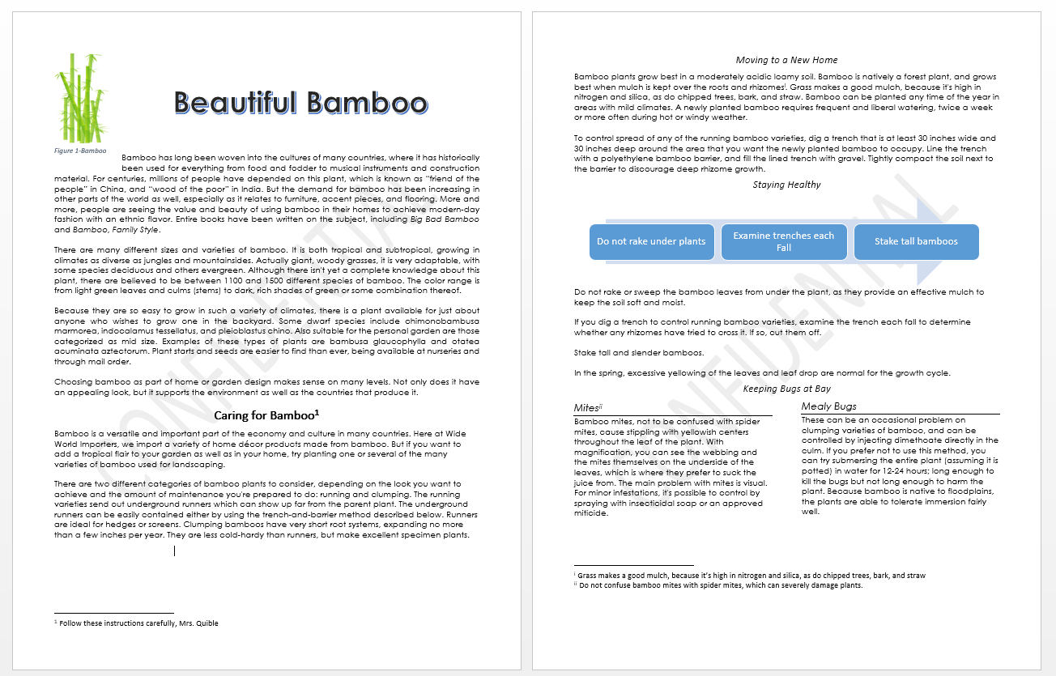
- Save again. Copy this file to Cobra for credit.
Figure 1--This is what it looks like

