During Super Bowl, the Real Action Will Be on Social Media (Infographic) 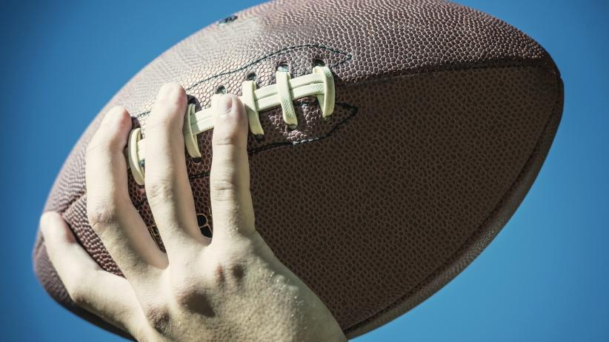

Image credit: Shutterstock.com
JANUARY 26, 2015
Whether or not you have a stake in this year’s Super Bowl match up between the Seattle Seahawks and New England Patriots, it’s entirely likely you’ll be watching – and chiming in on social media.
For brands – especially those who advertise or create Super Bowl social campaigns – that means everything. Last year’s game was the most watched TV show in U.S. history, averaging 111.5 million viewers, which means the brands that secured the coveted (and expensive – the average 30-second spot cost roughly $4 million in 2014) air time, got a major bump.
Social media insights and influence platform Crowdtap polled 6,000 viewers and 85 percent said they prefer the Super Bowl with ads, rather than without, with 30 percent reporting that the commercials are their main reason for watching on game day.
Seventy-four percent of viewers said that they would “take action on social media” (i.e. post a status update or use a hashgtag) if a Super Bowl ad spurred them to it, and half said that they would share commercials to support their favorite brands. Not only that, 63 percent of viewers reported that they were extremely or somewhat likely to buy a product showcased in a Super Bowl commercial.
For more on the elements that make a memorable commercial, and last year’s most popular ads (unsurprisingly, there were puppies involved), check out the infographic below.
(Infographic on back)
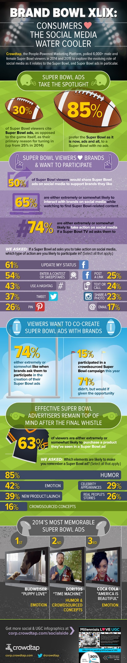
Like Twitter, Facebook's Super Bowl Game Plan to Include Ads Sold in Real Time

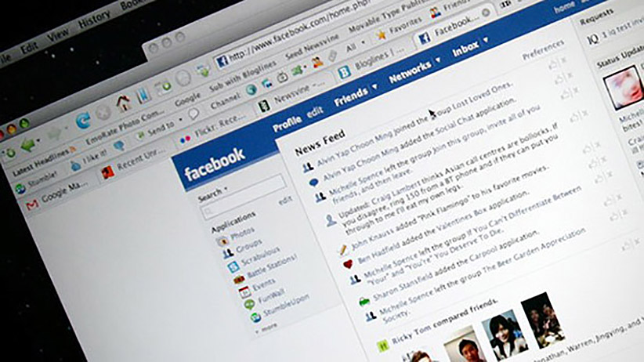
Image credit: Dave Rutt | Flickr
JANUARY 28, 2015
This Super Bowl Sunday, Facebook is deploying an all-new marketing game plan that will enable companies to purchase ads in real time.
Whereas Facebook previously sold Super Bowl ads based on users’ existing likes, profiles and demographic information, this marks the first time that the site will utilize new targeting features that customize audience clusters for advertisers as discussion about the game unfolds.
For instance, video ads triggered by the use of certain keywords (i.e Patriots, beer or uniforms) on Facebook could automatically start to play within users’ news feeds, according to Reuters.
While the strategy represents a first for Facebook, Twitter's platform has been a trailblazer in real-time marketing for years. In 2013, for instance, when a power outage suspended play for half an hour, Oreo tweetedout a now-viral ad quipping, “Power out? No problem. You can still dunk in the dark.”
The ad was the result of a 15-person social media team Oreo had assembled prior to the game to instantly respond to newsworthy occurrences.
These kinds of “war rooms” have now become de rigeur, Reuters reports. Twitter is working directly with 13 advertisers, including PepsiCo and Anheuser Busch, to create “unplanned” ads, complete with lawyers on hand to approve the spots.
As NBC is charging a record $4.5 million for a 30-second commercial during this year’s game -- which is expected to draw 100 million viewers -- marketers are increasingly considering ads created specifically for social-media outlets.
"There is a lot more fragmentation. TV is an important media; it's not as dominant,” Toyota’s director of traditional and emerging media, Dionne Colvin-Lovely, told Reuters. “We need to make sure we have a strong presence online and in mobile. It's more complicated now."

