Group 1
Blake
Larissa
Devlin
Ashlee
Group 2
Hidayat
Tim
Mason
Group 3
Mustafa
Nate
Andre
Group 4
Drew
Geigh
Jarid
Group 5
Mitch
Justin
Khan

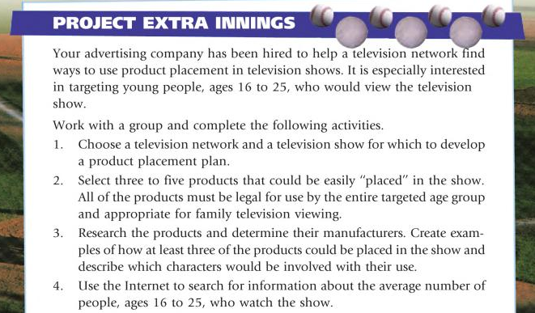
With you groups, complete the above 4 tasks. After you have gathered the information, put the information into a Google Presentation and share with Mrs. Crabtree as well as each member of your group. You should have at minimum the following slides:
- Title Slide – introduce your project, include names of group members
- Slide 1 – TV Network and TV show used to develop product placement plan
- Slide 2 – three to five products you would “place” in the show (include list as well as images of the products)
- Slides 3-5 – one slide for each product and their manufacturers, as well as how you would place them in the show and which characters would use them (use graphics to make this appealing)
- Slide 6 – Internet research results about average number of people (age 16-25) who watch the show
- Closing Slide – ending conclusion
- Resources – site resources used to collect information as well as graphics/images
THIS PROJECT WILL BE DUE BY END OF CLASS FRIDAY – Discuss overall ideas first and then split up the work and assign a responsibility to each group member!

