Photoshop: Caricature Assignment
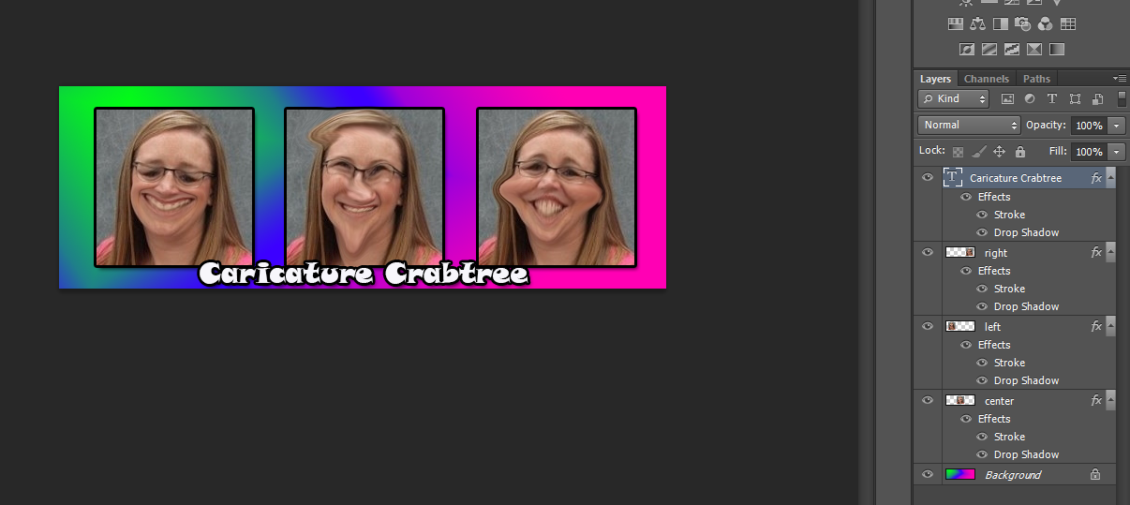
Using Photoshop, create a funny photo montage
- Create a new document:
  - 9 inches wide; 3 inches high or
  - 3 inches wide; 9 inches high
- Save as “LastName Caricature” (psd)
- Design a background – can use a solid color or a gradient fill
- Select one of your green screen photos
  - Open picture – crop – perfect square
  - Drag layer over to blank canvas – resize – then duplicate layer two more times
  - Move so you have an image at the left, center, and right – or top, middle, and bottom – evenly proportioned
  - Rename layers – left, center, right or top, middle, bottom
- On each layer, use Filter > Liquify – make yourself look funny!
- Add a drop shadow and stroke to each picture layer (ALT drag to other layers once you complete effects on one layer)
- Add a text layer – like above illustration – add stroke and shadow.
- Save again as a “psd”
- Once completed and perfect, save as a “jpg” and copy the “jpg” to “to be graded”

