Photoshop Review for Test
Create a collage using: fun1.jpg, fun2.jpg, and fun3.jpg
The collage:
- 10 x 10 inches
- Add a gradient background (bright colors)
- Add a black border to the gradient background
- Add text: “Family” – you figure out the size and color – trial and error
  - Add drop shadow and stroke
- Add photos after altering and following directions below. Resize as needed. All photos should have a drop shadow and bevel and emboss applied to them.
- Save as LastName_Review both as psd and jpg – copy jpg to “to be graded” folder
Fun1.jpg – do the following:
- Crop to remove part of top and bottom (don’t lose her feet though)
- Using the clone stamp tool, make a few more lilly pads in the water
- Use rectangular marquee with feather of 15 px and move to the collage
Fun2.jpg – do the following:
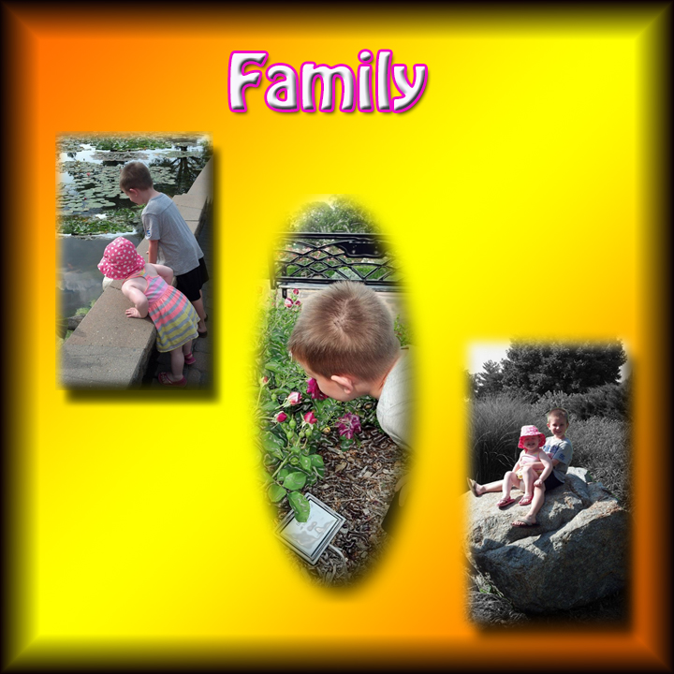
- Select the boy (quick selection works well)
- Select > inverse
- Apply the plastic wrap filter
- The boy should be clear – everything else should be blurred
- Use elliptical marquee with feather of 10 px and move to the collage
Fun3.jpg – do the following:
- Select the kids and rock (quick selection works well)
- Select > inverse
- Turn the background to black and white (Image > Adjustments > Black and White)
- Use rectangular marquee with feather of 15 px and move to the collage
Make sure you copy your completed jpg collage to “to be graded” folder in Cobra.
Other things you will need to know for test:
- Dodge tool (whiten teeth)
- Red eyes to fix photos
- Filters from gallery and liquify
- Borders – fill with color
- How to warp text

