ME in 5 – Fireworks Assignment
Using Adobe Fireworks, design a graphic – you are the topic – be highly creative!
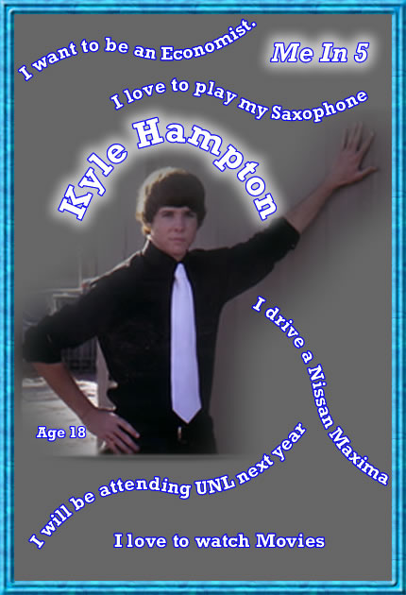
Requirements:
- Canvas size: 500 by 500 – start with a transparent canvas
- Save as “LastName_in5.png” to your Fireworks folder.
- Create some type of background
  - Draw a rectangle to fill the canvas
    - Fill with a solid color, pattern, or gradient
    - Change the outside stroke (pencil) color and size
    - Apply at least two filters to your rectangle
      - Emboss
      - Drop shadow
      - Bevel
      - Etc.
- Include/import your picture – use the magic wand to delete the background of your picture or feather the edges. Consider applying a filter to your picture (maybe a glow)
- Include your full name (at least first and last). Make sure the text for your name has an outside stroke – possibly some other filters
- Include your age
- Include 5 interesting facts about yourself – at least some text should follow a path
- Include the text “Me in 5”
- Experiment with new techniques – ask other students for suggestions for improvement
- When finished, copy the “png” file to “to be graded.” NOTE: this will be printed in color and displayed in our room.

*Tips to attach text to a path:
- Type your text
- Draw your path (either a shape or use the pen tool to draw a curved line)
- Select both (hold shift and use your black arrow)
- From the menu bar – select Text > Attach to path

