Photoshop – J_Flowers
Remove Jaiden’s dad
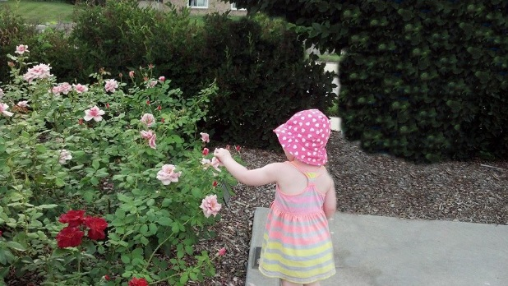
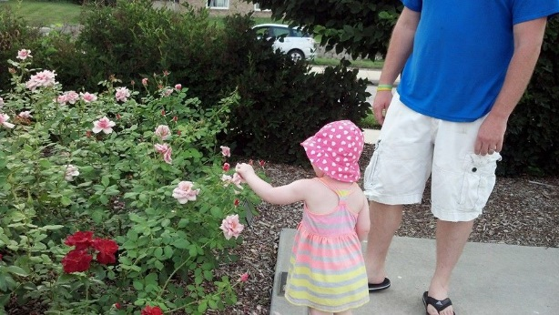

Final

- Open J_Flowers from your Photoshop folder
- Don’t forget to duplicate your image and duplicate your layer!
- Use the tools we have learned to remove the extra boy and improve the picture
- Add the text “Jaiden”
  - Add a Style/Warm to the text (your choice)
  - Add an effect (fx) to the text (your choice)
- Add a border of 25 pixels around the picture
  - Make sure you are not on the text layer, control + A to Select All
  - Select > Modify > Border (25 pixels)
  - Edit > Fill > Color (choose a color you like), then control + D to Deselect
- Save as a psd and jpg (please add your last name to the file name)
- Copy the jpg to your “to be graded” folder
Photoshop – J_Flowers
Remove Jaiden’s dad

Final

- Open J_Flowers from your Photoshop folder
- Don’t forget to duplicate your image and duplicate your layer!
- Use the tools we have learned to remove the dad and car AND improve the picture
- Add the text “Jaiden”
  - Add a Style/Warm to the text (your choice)
  - Add an effect (fx) to the text (your choice)
- Add a border of 25 pixels around the picture
  - Make sure you are not on the text layer, control + A to Select All
  - Select > Modify > Border (25 pixels)
  - Edit > Fill > Color (choose a color you like), then control + D to Deselect
- Save as a psd and jpg (please add your last name to the file name)
- Copy the jpg to your “to be graded” folder

