InDesign Type Tool Path & Effect Practice
You can format text to flow along the end of an open or closed path of any shape. Type on a path has an in port and an out port just like other text frames, so you can thread test to and from it. In addition, you can apply options and effects.
Create the following using InDesign. When complete, save as an INDD file and export as a PDF for Print. Hand the PDF into your “to be graded” folder.

- Happy Thanksgiving Path (LastName_Thanskgiving.indd)
  - Use the Pen tool to draw a path like below.
  - Using the Type on Path tool add the text, “Have a Happy Thanksgiving!”
  - You may choose the font.
  - Choose a fall color for your text and add a drop shadow
  - Adjust the kerning if necessary due to the curves in your path!
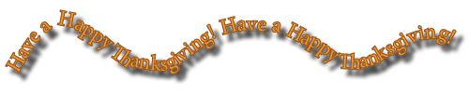
  - Make sure that the pen line does not have a stroke visible.

- Go Rockets Path (LastName_LNERockets.indd)
  - Use the Pen tool to draw a rounded path
  - Use the Type on Path tool add the text, “Lincoln Northeast High School, Go Rockets!”
  - Again, you may choose the font and size. Make sure that the size you chose will fit nicely between the two shapes.
  - Choose a color for your text and add a bevel effect and a drop shadow
  - Adjust the kerning if necessary due to the curves in your path!
  - Make sure that the pen line does not have a stroke

- Path Type Effects (LastName_PathTypes.indd)
  - Use the Pen tool to draw one curved path going down. You will need to duplicate this 4 additional times.
  - Using the Type on Path tool add the text, as seen below and apply the appropriate Path Type Option. (Type > Type on a Path > Options – Stair Step, Skew, 3D Ribbon, Rainbow, Gravity)
  - Again, you may choose the font, size and color.
  - Choose a different effect for each (Object > Effects)
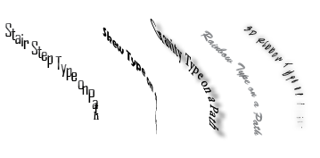
  - Make sure that the pen line does not have a stroke visible
- Create your own Shape Poetry (LastName_ShapePoetry.indd)
  - Shape Poetry is when the text takes on the shape of its subject
  - Use the appropriate tools to draw your shape, then attach the text to the path.
  - Again, you may choose the font, size and color
  - You must add some type of effect to your text
  - Remove the stroke of your shape
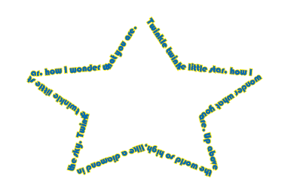
  - Below is an example, however, you must come up with your own!

