Adobe Photoshop – Fix Couple – Image Correction Basics
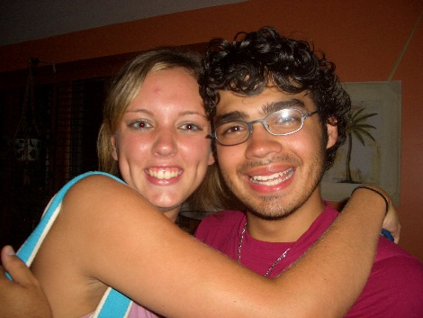
Open “Fix_Couple”
Make a Duplicate Image (Image > Duplicate – add your last name)
Make a Duplicate Layer (Layer > Duplicate)
Save as a “psd” file
Do the following to improve the looks of this picture:
- Crop so you have just a close-up of their faces
- Fix the Red Eyes with the Red Eye Tool
- Fix the glass glare and shiny skin with the Smudge Tool – this glass glare will be hard to fix – do the best you can – be careful not to overcorrect!
- Use the Spot Healing Brush to fix blemishes
- Use the Dodge Tool to whiten the girl’s teeth
- Use the Clone Stamp Tool to get rid of the palm tree picture on the right side – clone the darn orange background
- Add the text “Peggy and Marc” in a color of your choice
  - Add a Style/Warp to the text (make sure the warp is obvious)
  - Add both a stroke and drop shadow use the “fx” icon
- Add a black border of 50 pixels around the picture – steps given below:
  - Make sure you are not on the text layer (look at bottom right of screen)
  - Select > All (or control-A)
  - Select > Modify > Border
    - Width 50 pixels
  - Edit > Fill
    - Change color to black
  - Select > Deselect (or Control-D)
- Save as a “psd” and again as a “jpg”
- Copy the “jpg” to your “to be graded” folder in Cobra

Photoshop – Green Screen Pictures
Look at all of your “green” photos. Pick the photo that you like the best and do the following:
- Open and duplicate both image and layer – save as “LastName_favorite.psd”. Close original.
- Crop to get rid of unwanted background – should only see green background – but not too much.
- Use the Zoom Tool to adjust appearance on screen. Do the following:
  - Fix blemishes (spot healing)
  - Fix red eye if necessary
  - Fix glasses glare if necessary (smudge)
  - Fix teeth and whites of your eyes (dodge)
- Add your first and last name – use warped text – add text effects such as bevel, stroke, drop shadow
- Add a border around the entire picture – follow these steps
  - Make sure you are on the correct layer (not the text layer)
  - Select – All
  - Select – Modify – Border
  - Edit – Fill – pick a color
  - Select – Deselect
- Resize image using: Image > Image Size
  - Change the Document Size width to 4 inches – height should automatically change
- Save as a PSD file – this retains all your layers
- Save again – as JPG
- Copy “LastName_favorite.jpg” to “to be graded”
- View as “large icons” from “to be graded” to make sure you handed in the correct file
For each of your other “green” photos:
- Open Photoshop – open picture – duplicate (Image > Duplicate) – name it “LastName_Position” (e.g., Crabtree_CloseUp) – close original
- Duplicate layer (Layer > Duplicate Layer)
- Save as “LastName_Positioin.psd”
- Crop – get rid of “garbage” edges but keep all of you!
- Use the Zoom Tool to adjust appearance on screen. Do the following:
  - Fix blemishes (spot healing)
  - Fix red eye
  - Fix glasses glare (smudge)
  - Teeth and whites of your eyes (dodge)
- Save your “psd” file
- Save again as a “jpg”

