Fireworks – Animations and Text on a Path
- Create the following graphic using these guidelines:
  - Canvas size: 900 x 200 – transparent canvas
  - Animation that types out: Go Rockets – make the text as large as you can but it needs to fit on your canvas! Choose a “thick” font style – apply an outside stroke to each letter – fill of the letters should be white or black, outside stroke should be a dark purple
  - Save and export as a transparent animated gif – use the file name: LastName_Rockets.gif
  - Copy the animated gif file to “to be graded” – do not turn in the “png” file – a “png” cannot have animation!
- Look at the bottom of this handout. Create a graphic similar to one of the examples. You must include text that follows a path!
  - You decide the canvas size
  - This is NOT an animated graphic
  - Save as a “png” using the filename: LastName_PathGraphic.png
  - Copy the “png” file to “to be graded”
- Create another animated graphic using these guidelines:
  - You decide a canvas size
  - You decide text for your animation and other characteristics
  - Save and export as a transparent animated gif – use the filename: LastName_AnimationChoice.gif
  - Copy the animated gif file to “to be graded”
If you have time, create a 4th and 5th graphic – continue to experiment with Fireworks – don’t just quit!

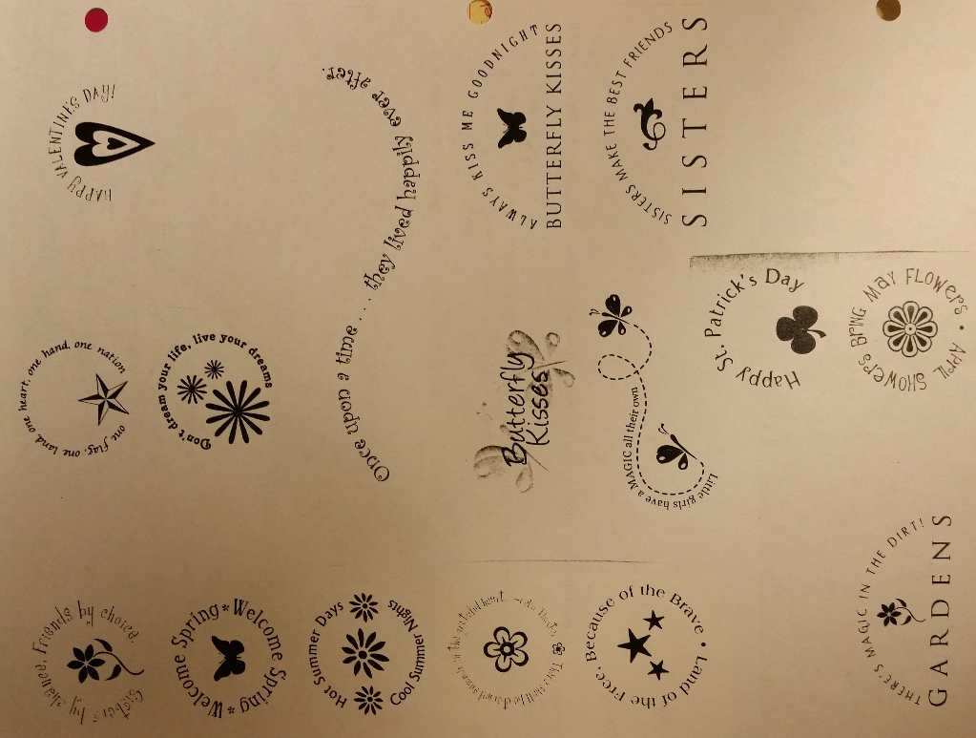
Text on a path examples (#2 above):

