College Football Assignment
College Football Team: ______________________________________
Part 1: Answer the following questions about your selected college football team:
- What city is the location for your university?
- List ten points of interest about the city (location of your university)?
- How many students are enrolled at your university?
- What is the cost of tuition for one credit hour at this university?
- What is the mascot for your university?
- How many people does the football stadium hold at your university?
- What is the official athletic gear company for your selected university?
- List the 2015 football schedule (dates and opponents):
Date | Opponent | Home/Away Game
Part 2: Design a professional poster that advertises your college team’s football schedule.
Design your poster on a piece of construction paper or you may choose to use a computer program (e.g., Photoshop, Word, etc.). You can find picture off of the internet if needed or hand draw them. You should show pictures of your team’s campus and stadium, fans, mascot, etc. The poster should include dates and opponents. The poster should have space where fans can record the scores of games. (HINT: look up examples of schedule poster online during your research – do not just copy what they have used, but gather ideas for your poster!)
Example:
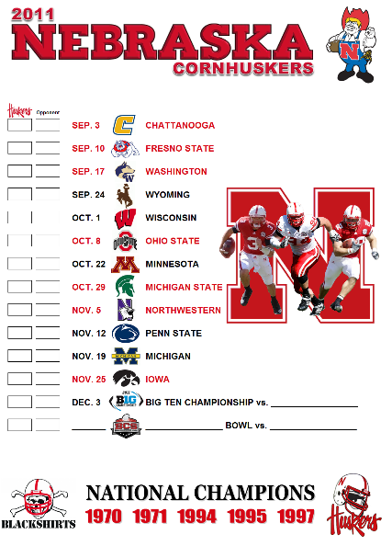

Part 3: Answer the following questions related to Marketing Mix and Core Marketing Standards.
- Describe the marketing mix for the football schedule poster you just created:
  - Product
  - Distribution
  - Price
  - Promotion
- Describe the core standards of marketing for the football schedule poster you just created:
  - Distribution
  - Marketing-Information Management (describe your demographics/target market too!)
  - Pricing
  - Product-Service Management
  - Promotion
  - Selling

