PHOTOSHOP CLONE PROJECT
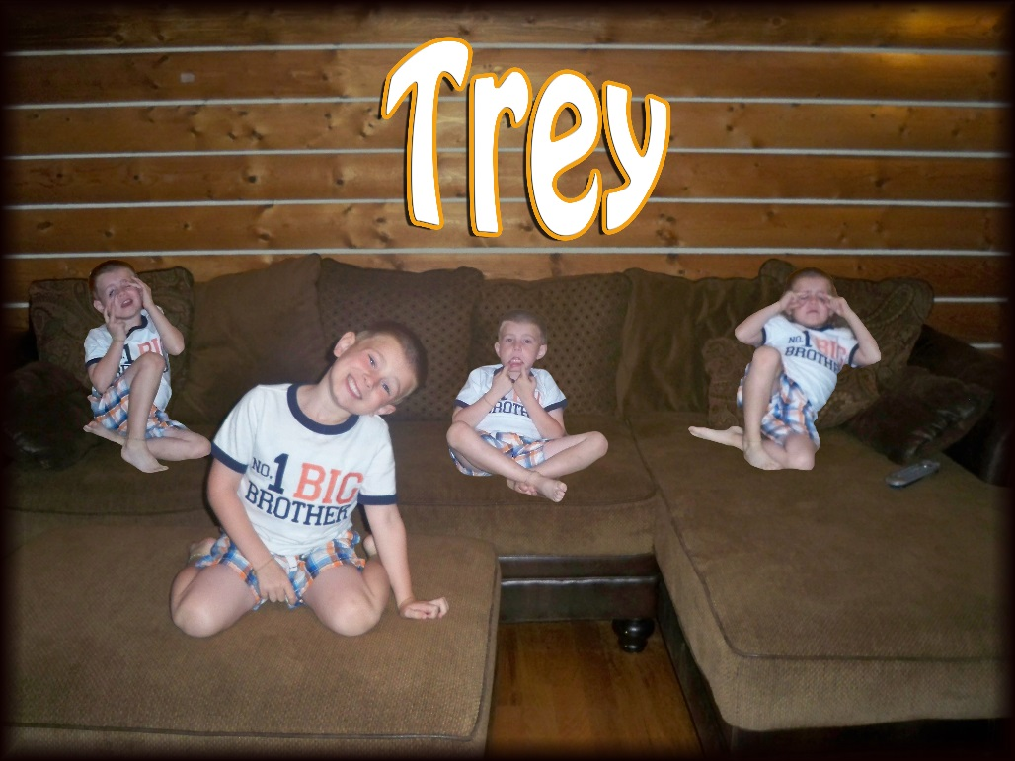
GUIDELINES
Using a camera on a tripod, capture at least five images of yourself posing (not just standing straight up!). It is important that the camera remain as still as possible. It would not hurt to take a few extra shots, just in case. Think about where you are for each picture and make sure that you are not covering yourself up with other pics.
- Take a minimum of FIVE photos of yourself (or have someone else) using a tripod. I’d take a few extras.
- Copy the photos to your computer. Open all of your pictures – save the one that you would like as your background image as LastName_Clone.psd.
- One picture at a time, use the selection tools to select you and copy. You will also need to choose refine edge to clean up your selection prior to copying. Then go to LastName_Clone.psd and choose Edit > Paste Special > Paste In Place. You may then need to use the eraser tool on the new layer to “clean it up.”
- If you notice any problems with the photos (especially colors if you didn’t use a flash or depending on the length of the subject from the lens), you might need to modify the Hue/Saturation on a specific layer to better match.
- You must have at least four images of yourself in your clone photo. If you want more, go for it.
- If you need to make any other changes or adjustments to your photo (crop, size, etc.), do so. You want it to look realistic.
- Add your name in a “cool” text (use bevel, drop shadow, etc.) with a warp someplace on the project.
- Add a border - first select all (CTRL + A – make sure you are not on your text layer), then choose Select > Modify > Border – change the pixels to a number between 50 and 100. Then choose Edit > Fill – under “Contents – Use” click on “Color” and pick a color of your choice.
- Save as a JPG and PSD in your Photoshop folder, then copy the JPG to your To Be Graded folder.

