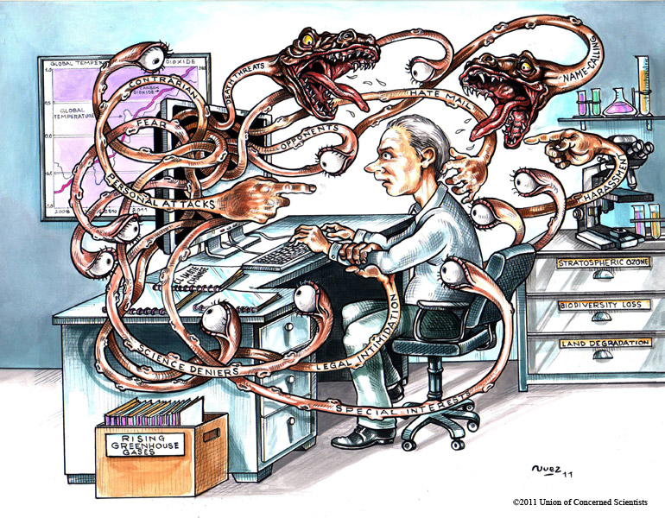
Science Controversy Cartoons

These cartoon are depictions of scientific controversies seen throughout the world. They are based generally on the way certain people view scientific advancement, evidence and its effect on people, politics, and the rest of the world.

- Take a few minutes and pick a cartoon to study.
- Consider what the central theme of the cartoon is. Who is the center of the issue?
- Look at the surroundings and try to determine what the message is. Describe the cartoon and what it says.
- Consider who is affected on both sides of the issue.
- Who benefits from science in the cartoon? Who doesn’t benefit?
- What is the major problem?
- How do we solve the problem?

Write your responses in a clear, concise manner. Use complete sentences. You will be graded on the content of your thoughts about the cartoon. Have fun and try to think outside the box.

