Adolescents Say Anti-Drug Messages Do Make a Difference

With federal grant support for prevention programs continuing to dwindle significantly, there has been a huge falloff in teens’ recalling any kind of exposure to drug abuse prevention messages over the past seven years.

However, results from a 2011 report from the University of Michigan’s Monitoring the Future (MTF) study – the largest tracking survey on teen drug abuse – were encouraging in that teens themselves report drug-prevention messages to be effective. This is indeed important information as we continue the on-going battle of substance use in our kids.

The MTF survey also measures teen attitudes about drug and alcohol use, including perceived harmfulness and disapproval, factors that can predict future substance abuse. The perception among teens that regular marijuana use is harmful decreased among 10th and 12th graders, but declined the most among the youngest group of 8th graders. This continued decline begs the questions: “will it lead to increased use in the future?” and “what will the impact of legalizing its use in Colorado and other states have on teen’s beliefs and attitudes regarding marijuana?”

Increases in teen use of illicit drugs correlate with decreased support for anti-drug messages.
“Children are not learning as much through the news media about the health consequences of using many dangerous drugs. It is important that we get that information to them by other means – through prevention messages, in schools and through their families,” said Steve Pasierb, President and CEO of The Partnership at Drugfree.org.

“Above The Influence” (ATI) a drug and alcohol prevention campaign, formerly funded through federal money, will shift from expensive television ads to lower-cost digital and social media campaigns; concentrating on reaching teens where they spend much of their time, such as Tumblr, Instagram and Facebook. As an example of how effective the Above The Influence messages are, 12 percent of those who said they had not seen the drug abuse messages reported marijuana use compared to only 8 percent of students who had reported familiarity with the campaign.

“The new data confirms that the campaign messages are having the intended positive effect on teens and that they are in fact working,” said Pasierb. “The alarming drop in the number of messages teens are seeing or hearing today is especially disturbing because the kids themselves report these messages are effective in keeping them from using drugs.”

While the exposure to drug-prevention messages is down significantly, the effectiveness of the messages did not reflect the same dramatic drops, and for the most part remained constant. Between 2003 and today, the proportion of teens that agreed that the commercials made them, to a great extent, less favorable toward drugs remained fairly stable. Similarly, the percentage of teens who agreed that drug-prevention messages made them less likely to use drugs in the future also remained stable, although they reported they are exposed to fewer messages.

“We recognize that teens are a tough audience – they don’t like to be lectured or told what not to do and they don’t worry about their mortality,” said Allen Rosenshine, Vice Chairman and Executive Director of The Partnership at Drugfree.org. “The insightful strategic messages offered by the ATI campaign take a different approach toward teens, reinforcing the fact that they value themselves and their aspirations above the debilitating and self-destructive influence of drugs. Over time, this has proven far more effective than the more traditional, negative anti-drug messages that today’s teens largely ignore.”

So remember, while they may appear dazed or bored during these anti-drug prevention presentations, they are listening and hearing the message, and you ARE making a difference!

(Source: www.drugfree.org)

10 Tips for Building Resilience in Children & Teens

We all can develop resilience, and we can help children develop it as well. It involves behaviors, thoughts and actions that can be learned over time.

- Make Connections
Teach children how to make friends, including the skill of empathy, or feeling another's pain. Encourage a child to be a friend in order to get friends. Build a strong family network to support a child through his or her inevitable disappointments and hurts. At school, watch to make sure that one child is not being isolated. Connecting with people provides social support and strengthens resilience.

- Help Your Child by Having Him or Her Help Others
Children who may feel helpless can be empowered by helping others. Engage a child in age-appropriate volunteer work, or ask for assistance yourself with some task that he or she can master. Brainstorm with children about ways they can help others.

- Maintain a Daily Routine
Sticking to a routine can be comforting to children, especially younger children who crave structure in their lives. Encourage a child to develop routines.

- Take a Break
While it is important to stick to routines, endlessly worrying can be counter-productive. Teach a child how to focus on something besides what's worrying him or her. Be aware of what a child is exposed to that can be troubling, whether it be news, the Internet or overheard conversations, and make sure the child takes a break from those things if they trouble him and her. Although schools are being held accountable for performance on standardized tests, build in unstructured time during the school day to allow children to be creative.

- Teach Self-Care
Make yourself a good example, and teach children the importance of making time to eat properly, exercise and rest. Make sure a child has time to have fun, and make sure that every moment of his or her life is not scheduled so that there is "down time" to relax. Caring for oneself and even having fun will help a child stay balanced and better deal with stressful times.

- Move Toward Goals
Teach a child to set reasonable goals and then to move toward them one step at a time. Moving toward that goal — even if it's a tiny step — and receiving praise for doing so will focus a child on what he or she has accomplished rather than on what hasn't been accomplished, and can help build the resilience to move forward in the face of challenges. At school, break down large assignments into small, achievable goals for younger children, and for older children, acknowledge accomplishments on the way to larger goals.

- Nurture a Positive Self-View
Help a child remember ways that he or she has successfully handled hardships in the past and then help him understand that these past challenges help him/her build the strength to handle future challenges. Help a child learn to trust himself/herself to solve problems and make appropriate decisions. Teach a child to see the humor in life, and the ability to laugh at one's self. At school, help children see how their individual accomplishments contribute to the well-being of the class as a whole.

- Keep Things in Perspective & Maintain a Hopeful Outlook
Even when a child is facing very painful events, help him/her look at the situation in a broader view and keep a long-term perspective. Although a child may be too young to consider a long-term look on his/her own, help him or her see that there is a future beyond the current situation and that the future can be good. An optimistic and positive outlook enables a child to see the good things in life and keep going even in the hardest times. In school, use history to show that life moves on after bad events.

- Look for Opportunities for Self-Discovery
Tough times are often the times when children learn the most about themselves. Help a child take a look at how whatever he/she is facing can teach him/her "what he/she is made of." At school, consider leading discussions of what each student has learned after facing down a tough situation.

- Accept That Change is Part of Living
Change often can be scary for children and teens. Help a child see that change is part of life and new goals can replace goals that have become unattainable. In school, point out how students have changed as they moved up in grade levels and discuss how that change has had an impact on the students.

(Sources: www.apa.org; www.psychcentral.com; www.raisingresilientkids.com)

Smokeless Tobacco a Growing Risk for Youth

E-cigarettes – officially named electronic cigarettes – are growing in popularity and use among students. The National Youth Tobacco Survey shows that the percentage of high school students who reported ever using an e-cigarette rose from 4.7 percent in 2011 to 10.0 percent in 2012.
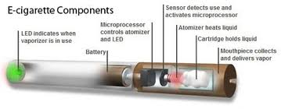
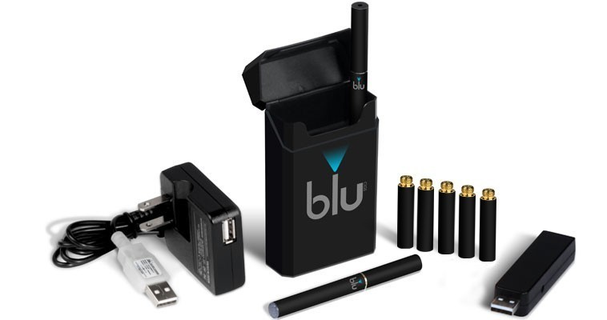

Electronic cigarettes look a lot like real cigarettes, are battery powered and often (but not always) contain liquid nicotine either from tobacco plants or a synthetic version. They allow a user to inhale the vapor, called “vaping”, without fire, smoke, scent, ash or carbon monoxide. The user inhales through a mouthpiece and the air flow triggers a sensor that switches a small battery-powered heater. The heater vaporizes the liquid cartridge as well as propylene glycol (PEG), theatrical smoke. The user gets a puff of hot gas that is absorbed through the lungs. When the user exhales, there is a cloud of PEG vapor that quickly dissipates. E-cigarettes can come in a variety of flavors including: apple pie, banana split, blueberry, caramel, chocolate, coffee bean, cool mint, raspberry, smoky bacon, very vanilla and white chocolate – which makes them especially attractive to young people. The cartridges also come in a variety of nicotine strengths ranging from zero to 24 mg. Cartridges are good for several uses – equivalent to about half a pack to 1 ½ packs of cigarettes. The e-cigarette comes in many shapes and sizes and range in price from $20 to $100 with the liquid refills ranging from $6 to $20.

According to establishments in the Lincoln area, they will not sell e-cigarettes to customers under 18, even though Nebraska law prohibits only sales of tobacco, not e-cigarettes, to customers under 18. That could be changing. The State Legislature's General Affairs Committee recently met to discuss a potential e-cigarette sales ban for minors. “I'm concerned about e-cigarettes, too,” said the committee's chairman, Sen. Russ Karpisek. “There aren't that many studies on what are the long-term effects. I think they're a great idea for people trying to quit smoking, but do we really want 16-year-old kids being able to buy them?”

In Nebraska, the Smoke-Free Air Law doesn’t prohibit e-cigarettes since the product is not “lit”. As a result, they could be used indoors. Schools across Nebraska have experienced students attempting to use e-cigarettes in the school building. Several schools have handled this by using the language “Engaging in the selling, using, possessing or dispensing of alcohol, tobacco, narcotics, drugs, controlled substance, inhalant or being under the influence of any of the above; or possession of drug paraphernalia. Use of a controlled substance in the manner prescribed for the student by the student’s physician is not a violation. The term “under the influence” has a less strict meaning than it does under criminal law. For school purposes, the term means any level of impairment and includes even the odor of alcohol or illegal substances on the breath or person of a student; also, it includes being impaired by reason of the abuse of any material used as a stimulant. Engaging in the selling, using, possessing, or dispensing of an imitation controlled substance as defined in Section 28-401, of the Nebraska statutes, or material represented to be alcohol, narcotics, drugs, controlled substance or inhalant. Students in violation of these rules are subject to immediate confiscation of the electronic cigarette and disciplinary consequences, such as detention or suspension. Students seen using electronic cigarettes in school or on school grounds will be suspended immediately.”

Other concerns that e-cigarettes raise is the ability for the cartridges to be filled with substances other than nicotine such as hash oil, also known as dabs, shatter, or earwax. Hash oil contains THC, the active ingredient in marijuana. Hash oil cartridges are available to purchase online and from head shops, and recipes to make it yourself at home can be found on the internet.

(Sources: www.cdc.gov; www.webmd.com; http://dhhs.ne.gov; www.omaha.com; www.lps.org)

Spitless Tobacco – marketed as a safe alternative to smoking cigarettes – is fast becoming an appealing product to teens. It is being sold as a complimentary product to cigarettes, sending the message that you can get your nicotine fix whether smoking is allowed or not.

With the increase in smoking restrictions, tobacco companies are looking for alternative products to reach smokers. Many of these products are enticing young smokers by hiding addictive products behind candy flavors.

These products, in a variety of styles and brand names such as Orbs, Snus, and Taboka, are smokeless and spitless that often dissolve in a user’s mouth. Orbs, similar to small pieces of candy very closely resembling a Tic Tac, come in flavors such as “fresh”, “mellow” or “mint” and dissolve in the mouth. Snus comes in a teabag-like pouch that a user puts between the cheek and gum and then discards after about 30 minutes. Sticks and strips also dissolve in the mouth.

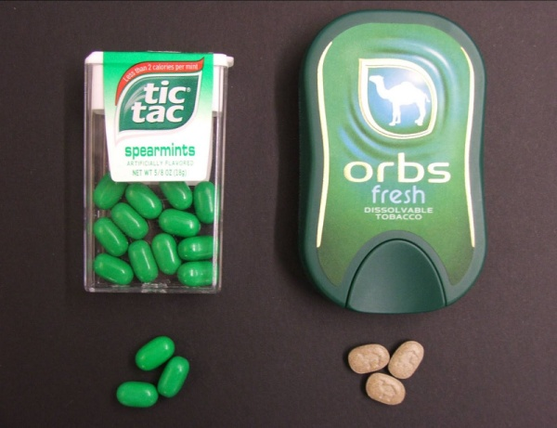
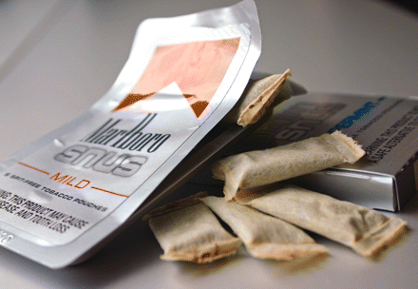

Their similarities to candy products pose serious poisoning risks to young children. Results from a Center for Disease Control Youth Risk Behaviors survey found one out of three teens incorrectly identified flavored tobacco as candy. Almost 40% of surveyed people younger than 18 identified Camel Orbs Fresh as mints or candy based on its packaging. Twenty-seven percent of respondents who did not currently use tobacco said they would try Orbs based on the packaging.

While the risk of lung cancer is decreased as compared to smoking, users increase their risk of mouth cancer, and many of the same risks of chewing tobacco are still present, from heart disease to cancers. There are also still ugly social effects including bad breath and stained teeth.

All in all, these are still tobacco products – dangerous and addictive – and there is no significant scientific evidence to suggest it is a safer alternative to cigarettes.

(Sources: http://thenationshealth.aphapublications.org; http://voices.yahoo.com)

