Ms. Haze’s Plans for the Week of May 1st-5th, 2017

 | Monday, 1st | Tuesday, 2nd | Wedn., 3rd | Thursday, 4th | Friday, 5th
Large Group  Grandma MARY:  Mary works on shape and color of the week as well as letter Mm craft | Letter of the Week:  Letter Mm  GOLD Objective : Star helper does counting jobs, rhyme, pattern and shape and color.  Second Steps:  Speaking up assertively  Large Group:  -Practice Graduation Performance  -Introduce Letter Mm and Song  -Read “The Tiny Seed” by Eric Carle  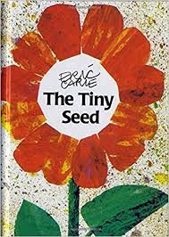 | Letter of the Week:  Letter Mm  GOLD Objective : Star helper does counting jobs, rhyme, pattern and shape and color.  Second Steps:  Speaking up assertively  Large Group:  -Practice preschool graduation  -Introduce how to spell Letter Mm  -Read “Watch the Tiny Seed” by Eric Carle | Letter of the Week:  Letter Mm  GOLD Objective : Star helper does counting jobs, rhyme, pattern and shape and color.  Second Steps:  Speaking up assertively  Large Group:  -Practice Preschool Graduation  -Read “Growing Vegetable Soup” and talk about the type of vegetables and flowers we will be growing. 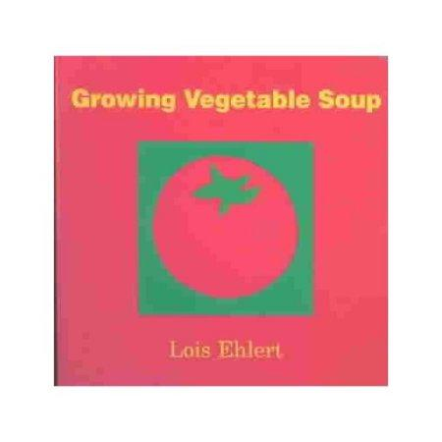 | Letter of the Week:  Letter Mm  GOLD Objective : Star helper does counting jobs, rhyme, pattern and shape and color.  Second Steps:  Speaking up assertively  Large Group:  -Practice Preschool Graduation  -Read: “Seeds Get Around.” Students will do think-pair-show to see if they can tell their partner 3 ways seeds get around.  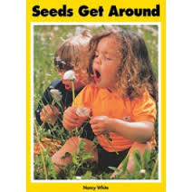 | Letter of the Week:  Letter Mm  GOLD Objective : Star helper does counting jobs, rhyme, pattern and shape and color.  Second Steps:  Speaking up assertively  Large Group:  -Practice Preschool Graduation  -Read: “Seeds Get Around”. We will be cracking open a coconut and trying coconut water at large group and then graphing if we like it!
Modifications | Azlan: smiley chart as a reinforcer and carpet square at large group if needed  Aailyah: Program throughout all transitions and check her goal sheet, circle if was at KT (keep trying), 1 (Okay), 2 (Great!) Focus on the praising for positives  Ler Poe: sits on carpet square during large group. Use file folder activities as needed.  Parker: use fidget if needed/1.2.3.  PECS for Sonny
Small Group | Small Group:  Paint Our Flowers Pots! | Small Group:  GOLD objective: fine motor practice with Handwriting Without Tears Centers:  Letter Mm  Center 1: Chalk and Sponge Boards  Center 2: Handwriting sheet and making letter Mm with 4 big lines | Small Group:  No Small Group: Library Day @ 1:55! | Small Group:  We will Plant our Seeds in our pots! | Small Group:  Letter M Art  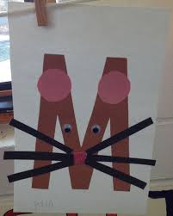
Modifications
Extra Weekly Activities/Home Visits | Eval @ 9:30 | Home Visit with Ler Poe @ 10:15  Holmes Kindergarten Round-up from 5:30-7:00 | Home visit with Azlan and tour of Campbell @ 9:30 | Home visit @ Eastridge with Mana and Thu | Kahoa team is visiting Parker from 2:30-1:30

