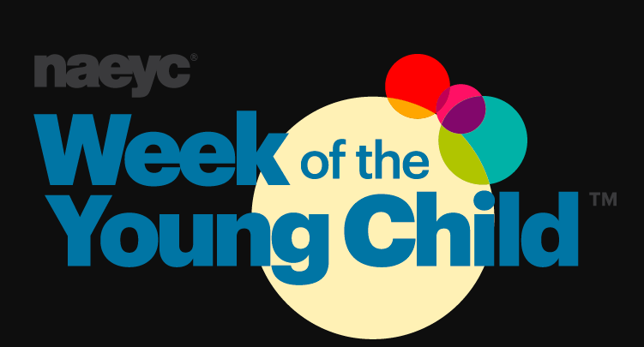

Hello Families,
We have been doing some great things learning about tubes and tunnels. We will be taking a break from tubes and tunnels to celebrate the “Week of The Young Child”.

The Week of the Young Child™ is an annual celebration hosted by the National Association for the Education of Young Children (NAEYC) celebrating early learning, young children, their teachers, and families. This year's event is April 8–12, 2018! You can check out more information at the website https://www.naeyc.org/events/woyc/overview

We will be celebrating with daily themes this coming week.

Music Monday! April 8, 2018

Sing, dance, celebrate, and learn

Tasty Tuesday April 9, 2018

Healthy eating and fitness at home and school

Work Together Wednesday April 10, 2018

Work together, build together, learn together

Artsy Thursday April 11, 2018

Think, problem solve, create

Family Friday April 12, 2018

Sharing family stories

We would love for you to come join us on Friday to play games during our small group time in the classroom. You can bring your child favorite age appropriate (ages 3-5) game to play with partners. If you would like to join us please just check in at the front and come on down.

AM class choice time will be from 8:40-9:00
PM class choice time will be from 2:20-2:40

Thank you for all you do and we hope to see you there!
Mrs. Losey and Ms. Kim

