Business Management Name____________________________________________________
Strengths Finder
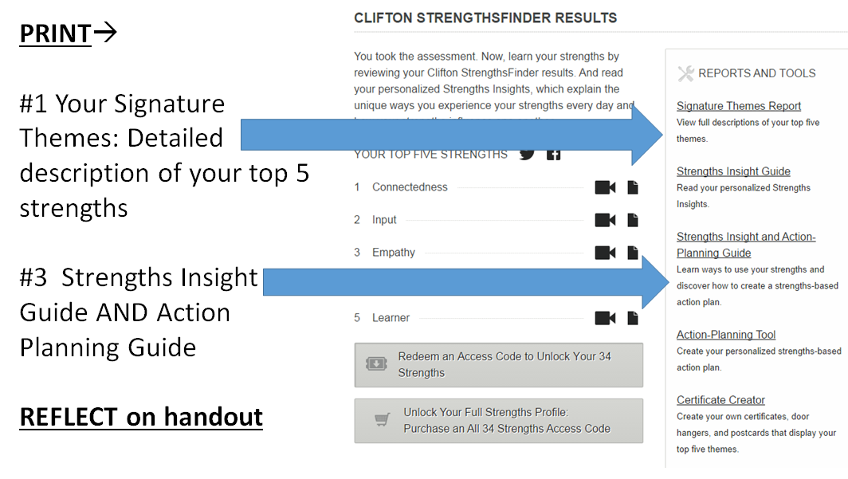
- What is your 1ST STRENGTH?________________________________________
- What is your shared theme description? Include other things learned:

- As you read your personalized strengths insights, what words, phrases, or lines stand out to you? In other words, YES, THAT’S ME!!

- Out of all the talents in this insight, what would you like for others to see most in you?

- What is your 2ND STRENGTH? __________________________________________
- What is your shared theme description? Include other things learned:

- As you read your personalized strengths insights, what words, phrases, or lines stand out to you? In other words, YES, THAT’S ME!!

- Out of all the talents in this insight, what would you like for others to see most in you?

- What is your 3RD STRENGTH? __________________________________________
- What is your shared theme description? Include other things learned:

- As you read your personalized strengths insights, what words, phrases, or lines stand out to you? In other words, YES, THAT’S ME!

- Out of all the talents in this insight, what would you like for others to see most in you?

- What is your 4TH STRENGTH? __________________________________________
- What is your shared theme description? Include other things learned:

- As you read your personalized strengths insights, what words, phrases, or lines stand out to you? In other words, YES, THAT’S ME!!

- Out of all the talents in this insight, what would you like for others to see most in you?

- What is your 5TH STRENGTH? __________________________________________
- What is your shared theme description? Include other things learned:

- As you read your personalized strengths insights, what words, phrases, or lines stand out to you? In other words, YES, THAT’S ME!!

- Out of all the talents in this insight, what would you like for others to see most in you?

- SUMMARY OF STRENGTHS: How does this information help you better understand your unique talents? What will you do differently tomorrow (or in your future) as a result of this report?

- Review the Application section of your strengths report. Write down two action points that you will take for EACH strength below.
Strength___________________________ Action #1—
Action #2—
Strength___________________________ Action #1—
Action #2—
Strength___________________________ Action #1—
Action #2—
Strength___________________________ Action #1—
Action #2—
Strength___________________________ Action #1—
Action #2—
- How will you use your talents to achieve?

- Name two other strengths that you identify with on the Reference Card. Explain.

- What domains are your strengths in? Is there a dominant domain?

REVIEW THE OTHER RESOURCES ON THE WEBSITE. Write down additional key points you learn about your strengths throughout the handout (specifically #1-20)

